Introduction + Credits
In the recent era of Touhou LostWord, many things can be very confusing to the average player. This is why during the 1.5th Anniversary of this game, the original Advanced Combat Guide was created. Unfortunately, as most gacha games continue to evolve, previous data tends to become outdated or not useful. Fret not! For this updated 3rd Anniversary Advanced Combat Guide will be an all encompassing guide, filled with old and new information. Note that this guide will not have all information, the information it lacks will either be easy to find in-game or explainable inside of the (un)official discord server.
Discord: https://discord.gg/TCjp7VMTps
Tierlist: Touhou LostWord Community Tierlist - Google Sheets
Credits to: Minzhire, Kairyu, and Meeko for the original Advanced Combat guide.
Credits to: Alex393 and Kogasa for assistance during the creation of this guide.

Flash Updates/Quick Tips
The way to find the awaken multiplier of units has been found by yours truly! More information in the Damage Calculation section.
When loading into a battle, tips can often double the loading time. Turn them off in the menu tab on the far right of the home screen.
Stored power stacks additively.
Resonance skills do not stack in any manner with each other.
Added the “correct” chances for the primary effects of both freeze and para. This was really boring to test by the way.
Made how outspeeding works more clear.
Added the two other rank two era buffs that have some very very niche things with them.

Bullets and Bullet Lines
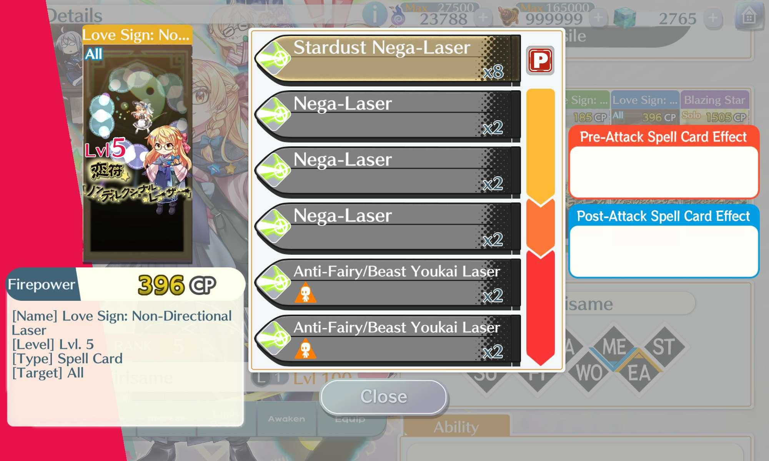
All Basic Shots, Spell Cards, and Last Words in LostWord consist of six bullets, or “Bullet Lines”. Each individual bullet line is made up of bullets, the amount of bullets, in-line effects, and a set element. The in-line effects will be covered later in this guide. Without using Spirit Power, only the first line is accessible. The remainder of the bullet lines in the attack activate as you boost. Consuming spirit power.
The community refers to how many lines gained from each boost in an x-x-x format. Each x represents the first, second, and third boost. In the example screenshot of L1 Marisa Kirisame, her bullet lines are 2-1-2. This means she gains 2 bullet lines for a single boost, 1 additional bullet line for 2 boosts, and 2 more bullet lines for 3 boosts. In total this means all attacks have 6 bullet lines which can be accessed through boosting. More on Boosting and Spirit Power mechanics later.
Note the difference between a bullet and a bullet line. A bullet line is a group of bullets, dictated by the number on the right bottom corner of a bullet line. A bullet refers to a singular attack or tic of damage. Back to the Marisa example. In the first bullet line of Marisa’s attack, there are 8 bullets. Each bullet in any attack, can give 1 of the following:
- A part of that bullet line’s damage.
- A singular break.*
- Whatever effect said bullet line may have.*
- A singular break of whatever anomaly break said bullet line has.**
- Spirit power recovery proportional to how many bullets land.
*This means that if 1 of a bullet line’s bullet connects, the bullet will induce that effect. If more bullets from the bullet line connect, there will be no additional effects. This does not apply to the secondary effect called absorb. As that increases hp based on targets hit. Should a 20% absorb line hit 3 enemies, one will recover 60% HP!
**This is extremely specific and requires a notation: In short, this means that if an enemy has an anomaly inflicted on them and then a bullet from a bullet line connects that has an anomaly break, the anomaly break of that bullet line will be “consumed” for the rest of the bullet line. It will not break the anomaly further even if more anomalies are inflicted on the same bullet line. Ie. Should both an anomaly infliction and an anomaly break be on the same line without any anomalies being inflicted prior, the enemy will lose 1 Barrier. If there were anomalies inflicted, those anomalies will be broken and the enemy will be left with 1 barrier status. What anomaly that is will depend on the specific line.

Bullet Tags
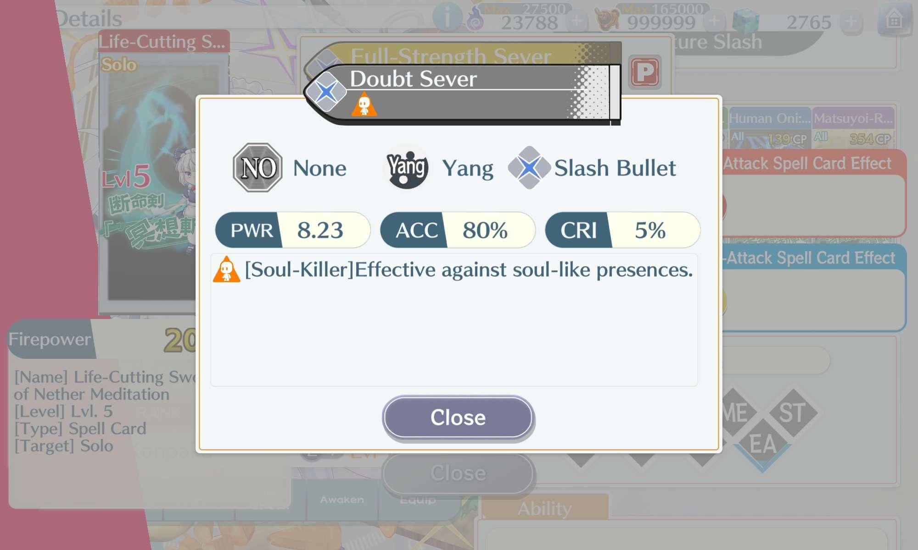
Every bullet can have one of several ‘tags’ attached to it, which you can check by tapping on the bullet in-game, or checking here on GamePress. There are a lot of tags and these should be viewed to understand their effects ahead of time.
A bullet type is simply what type of damage you’re dealing. There are many types and these can be viewed in game by looking at the side of a bullet line as can be seen with L1 Youmu above, or by pressing the bullet line and looking toward the middle left.
Here is a table of every bullet type:
 Ofuda - This bullet type looks like paper with a small symbol in the middle.
 Slash - As can be seen with Youmu above, this looks like an X.
 Energy - This looks like a fireball heading to the left.
 Laser - This…looks like a laser. Originating from the right and heading left.
 Liquid - This looks like a splash of water.
 Heavy - Looks like a cube.
 Sharp - Appears as 3 needles aimed to the left.
 Light - Looks like the sun and it’s rays.
 Missile - Appears very much like a literal missile facing to the left.
 Body - These appear as an orange fist.
 Normal - These appear as your typical real life bullet. Scary.
A bullet line is always one singular bullet type. A single attack can have up to 6 different bullet types. 1 different type per line.
Easily the most important tag is known as killer. Killer, also known as Anti, is translated in game as any attack line with “X-Killer”. This means that attack will always result in a Critical Hit if the opponent has that designation for the entire bullet line. For example, “Human-Killer” will always land a Critical Hit against Reimu Hakurei for the entire bullet line.
Enemies can also change what killer tags affect them. While an enemy may have loads of different killer tags like for example, S5 Utsuho Reiuji. During a battle the enemies might change their killer tag to become (most often) 1 tag. While S5 Okuu might have tags like Beast, God, Underworld, and so on during one gauge or HP bar, the next Gauge might end up being only Swimsuit. This means only characters who have the “Swimsuit-Killer” will always crit against S5 Okuu. You will often see this inside of Divergent Spirits. Which will be covered in a different section.

Damage Calculation
Damage is calculated as follows (with thanks to spmlk on Discord! ~ Changed to reflect modern understanding):
Hit Damage for a singular bullet line =
((Unit Attack x Buffs x Rank ii Buffs x Anomaly Specific Debuffs) + (Scaling Amount in Decimal x Buffs x Rank ii Buffs)) x (Critical hit multiplier + Buffs x Rank ii Buffs) x Awaken Multiplier/Shot Power Multiplier x Elemental Multiplier x Ability Multiplier x Unit Level x Base Power x Number of Bullets In The Bullet Line x Specific Card Details / (Enemy Defense x Buffs x Rank ii Buffs x Anomaly Specific Debuffs) x Ability x Specific Guard Details x Targeting Resistance = x*.336~.4 * bonus from special skills (ITS .336 LOWEST ROLL WHOOPSIE all calc sheet stuff is correct just a teansy typo)
Attack related and almost directly controllable.
Relating to critical hits, killers, and other things outside direct control.
Additional multipliers that are controllable.
The actual bullet itself.
The story card currently being used.
Total Attack is based on the unit’s attacking stat.
Buffs will be covered in the following sections.
Scaling Amount is the Base Scaling of an attack. For example, an attack may have 120% Hard scaling. Meaning 120% of that unit’s Defense is added to Attack. The type of Defense depends on whether the line is Yin or Yang (Yin Defense or Yang Defense). Slice will always scale off Agility.
Critical Hit Modifier is a multiplier to a hit that applies if it is determined to be a Critical Hit. This may vary depending on the attacker’s Crit Atk and the target’s Crit Def. This is also affected by divergent spirit rules. More on this later.
Bullet Level Modifier is a multiplier that is gained everytime one awakens a unit. To find the exact number, Take the already awakened CP value and divide it by the awaken value at 0 awakening level. For example, a character at awaken 0 has 317 and at awaken 5 it is 422. 422/317 or 1.3312302839116719242902208201893. However, the game rounds this to the hundredths place. So this character’s Bullet Level Modifier is x1.33.
Random Multiplier is a multiplier that applies to every hit and adds a level of randomness to damage, which can be anywhere from 0.336x to 0.4x. Because this randomness applies to every hit, the number will rarely fluctuate extremely. For the sake of sanity, Assume the exact middle or .368.
Target Defense is based on the target’s stats, composed of the Defense stat and modifiers that apply to the stat as shown. These are affected by DS rules. More on this later.
Trait Multiplier refers to only whether an attack is resisted, effective, or neutral. Covered later.
Targeting Resistance is the resistance/vulnerability to Solo/All attacks. More on this later.
Ability Multiplier is your ability and how it affects your damage output. More on abilities much later.
Example with the fan favorite mv patchouli. Assuming all of her buffs are maxed to her own ability. Earth weak. As well as 5 barriers.
( ((1450 * 1+.3(10)) + (2000 * 1.6 * 1+.3(10) * 1+.3(2))) * (2 + .3(10)) * 1.28 * 2 * 1.3 * 100 * 4.36 * 30 * 2) / (1000 * (1+.3(10)))
((5800 + 20480) * 5 * 1.28 * 2 * 1.3 * 100 * 4.36 * 30 *2)) / 4000
11,439,747,072/4000
2,859,936.768 * .368 * 2 = 2,104,913.461248
Patchoulis total damage at full buffs against a 1000 defense stat enemy with 10 defense up from just her first line is 2,104,913.461248. Do this for all lines and all weaknesses, add the total, and that is your damage. Complicated huh?

Barriers and Barrier Breaks
Playable units have 5 maximum barriers, only 4 may be consumed or restored. Upon consuming a graze, the character in question becomes immune to all attacks that do not have graze pierce. Graze pierce is a mechanic introduced in Sun EX. Barriers can be recovered by attack Pre/Post-ATK effects, Skills,Passives, Story Cards, and retrying the battle. They do not recover with time.
Enemies have a specified number of Barriers, often being 7, which they can not consume. Enemies can also have skills and spell card pre effects that recover Barriers.
Barrier Status (aka Barrier Anomalies) work the same for both players and enemies. One Barrier Status can be applied per existing Barrier, and all of them have individual turn durations that also have various effects.
Barriers can be broken by hitting bullet lines the enemy is weak to or by breaking their Barrier statuses. A Broken or Consumed barrier is simply deleted.
Attacks that break anomalies will first check for the relevant Barrier Status. Immediately break all relevant Barriers if even one hit belonging to a bullet line with the Barrier Status Break connects. Then cause Elemental Breaks. This means certain units can easily break 7 Barriers of an enemy in a singular turn, even if only one of their bullet lines have the appropriate elemental weakness.
F1 Koishi Komeiji is a great example of this concept as it is what makes her so powerful. Because the poison break triggers before the wood break on her AOE spell. She can easily break all 7 barriers to a wood weak foe by using her last skill and AOE spell with 1 boost.
Some units have their bullet lines trigger out of order, known as Overflow by the community. A7B Sakuya is infamous for having all her breaks activate almost instantly. It is difficult to exactly know which attacks/bullets have Overflow and when, but keep this very important mechanic in mind as it can greatly improve some units beyond what is known about on paper.

If a unit is brought down to 0 barriers, they are Full Broken. A Full Broken unit is stunned for the remainder of the turn as well as the following turn, with both of their Yang and Yin DEF reduced to a fourth of their original values. Additionally their buffs and debuffs are removed outside of CRIT and EVA (de)buffs.
You can not restore the Barriers of a fully broken Friend to revert them from being fully broken.
Not all attacks have overflow. An attack like the aforementioned F1 Koishi AOE spell will only break 6 barriers on a metal weak enemy. Due to her metal break triggering before her poison break, she will break one of the poison barriers early. Ending in only 6 total breaks.

Barrier Status

There are five different Barrier Statuses that Barriers can be inflicted with: Burn, Blind, Paralyze, Freeze, and Poison. Their effects are as follows (n is treated as the number of that Status applied to the unit):
Burn: The unit will lose 1.4*n% of their Max HP at the start of the turn. Cannot reduce HP below 1. Their Yin ATK and Yin DEF are also multiplied by 0.875^n. Is broken by Incineration.
Blind: The unit’s Accuracy is multiplied by 0.8^n. Is broken by Flash.
Paralyze: The unit in question has a 1-.9^n chance to be inflicted with stun (action canceled). This means at 1 barrier the unit has a 10% chance of stun and at 5 they have a 41% chance of stun. Their Evasion is also multiplied by 0.8^n. Is broken by Discharged.
Freeze: The unit has a roughly 15% per barrier chance to be inflicted with Delay (turn priority pushed back by 2). 2 Barriers of freeze means a 30% chance to be inflicted with Delay and so on. Agility is also multiplied by 0.875^n. Is broken by Melting.
Poison: The unit will lose 1.4*n% of their Max HP at the start of the turn. Cannot reduce HP below 1. Their Yang ATK and Yang DEF are also multiplied by 0.875^n. Is broken by Toxic.
All effects are multiplicative with buffs/debuffs. All Barrier Status have separate durations, dictated from the extra information on the Skill, bullet line, or Pre/Post Effect. The turn duration persists if you switch the inflicted unit to the rear guard. A unit cannot be applied with Barrier Status if they do not have a Barrier to apply Status onto or are immune to it via ability.
Barrier Status Effect Guide & List

Buffs and Debuffs

Levels of buffs and debuffs of the same type operate in additive fashion. If you give a unit 3 Levels of Yang ATK Up followed by 2 Levels of Yang ATK Down, the unit will be left with (3 - 2 = 1) 1 Level of Yang ATK Up.
Buff and debuff durations apply in a somewhat odd fashion. Whenever a Level, be it Up or Down, is applied the game checks the new (de)buff’s duration compared to the current duration on the unit. If the new duration is higher, the buff will apply for the higher duration. If the buff has a lower duration, the new duration is ignored. An exception being if the turn duration hits 0 at any point. If an enemy lowers Accuracy by 1 stage for 5 turns and a unit on your team buffs Accuracy by 3 stages for 1 turn, the Accuracy will buff once resulting in a net 0 Accuracy before applying the remaining accuracy up. Leaving the player with 2 Accuracy Up with a 1 turn duration.
All buffs and debuffs are removed from a unit upon the start of a new wave or when switching, irregardless of remaining duration.
Attack, Agility, and Defense buffs all multiply their respective stat by 1+.3n per Level above 0 and by (1 / 1 + 0.3n) per Level below 0. N being the amount of buffs or debuffs At 10 Levels of ATK, AGI, or DEF Up, the stat will be multiplied by 4x. At 10 Levels of ATK or DEF Down, the stat will be multiplied by 0.25x.
Crit attack and Crit defense specifically stack akin to Accuracy and Evasion (see next section) meaning 7 Crit attack and 3 Crit defense down to enemies = 10 Crit attack. The same is true for Crit II and Crit def down II.
This works the exact same with Rank II buffs. A Rank II buff looks the same as a Rank I buff but with the roman numeral for 2 on it. These stack independently from Rank I buffs and multiply with them. 1 Level of Yin ATK II and 10 Levels of Yin ATK result in (1.3*4 = 5.2) 5.2x Yin Attack.
As a result of this, buffs have diminishing returns, as the more Levels of a specific buff a unit already has (such as Yin Attack), the less that subsequent Levels will be worth relatively.
As an additional note, ATK Up and DEF Down are extremely powerful when combined as they wind up multiplying one another, similarly to a Rank II ATK buff (Yang ATK II, Yin ATK II), due to the fact that the damage formula boils down to Attack being divided by Defense. A mere 2 Levels of ATK Up combined with 2 Levels of DEF Down makes for 2.56x damage* (1.6 / (1 / 1.6)) or (1.6*1.6), and 10 Levels of ATK Up combined with 10 Levels of DEF Down makes for 16x ATK (4.0 / (1 / 4.0))!
This means that in a hypothetical scenario, a unit could have 10 Levels of ATK Up and 10 Levels of ATK II Up with an enemy having 10 Levels of DEF Down and 10 Levels of DEF II Down. This will result in said unit receiving a massive damage increase (4x4/1/4/1/4 or 4x4x4x4), a 256 DAMAGE INCREASE* to be specific! Buffs sure are powerful.
However, there are qualms with these numbers. Most units in the modern era gain sizable amounts of damage from their Scaling. While lowering an enemy’s Defense will always result in damage gained depending on how low it is, ATK buffs will not assume an ally has Scaling. It can be worth keeping an eye on your unit’s Scaling (Hard or Slice) and know which between ATK and their Scaling (Yin DEF/Yang DEF for Hard, Agility for Slice) to prioritize buffing.
Again, pay attention to what your unit scales off of and make the judgment or ask for help deciding what buffs they prefer in a situation and what card sticks to place on them.
Accuracy buffs will be covered in the next section as they are somewhat convoluted.
*with the assumption your unit has 0 Scaling value.

Accuracy and Evasion

Accuracy and Evasion both follow the same general rules as other buffs and debuffs - additional Levels are additive, and highest duration overrides. Where things get odd is that both Accuracy and Evasion are effectively added together on the same side: Accuracy Up is added with Evasion Down, and Evasion Up is added with Accuracy Down. For example, if you had a unit attacking with 3 Levels of Accuracy Up against an enemy with 2 Levels of Evasion Down, that unit would effectively have 5 Levels of Accuracy Up.
The way Accuracy works is that, if total Levels of Accuracy Up are positive, the attack has its base Accuracy multiplied by 1.2 per Level. If they are negative, instead the attack has its base Accuracy divided by 1.2 per level. Note that these are increases to the base value - so it takes far fewer Levels of Accuracy Up to make a 75% accurate bullet become 100% as opposed to, say, a 50% accurate bullet.
Accuracy caps at a x3 multiplier with a relatively weird way of canceling enemy Accuracy due to the way Accuracy functions. If a unit has 10 Levels of Accuracy and the enemy has 8 Levels of Evasion the unit will still connect with 80% base Accuracy bullets. As they have 2 Levels of net Accuracy, which in practice will be sure to connect unless other means prevent that.
Accuracy Rank II and Evasion Rank II still work as separate multipliers of x1.2, also stacking to x3 at 10 Levels.
VS Divergent Spirits can also lower Accuracy and increase Evasion (and vice versa). More information in the VS Divergent Spirits section.
Every hit of an attack checks its Accuracy separately, and its base Accuracy is determined by the line it belongs to.

Critical Hits

A Critical Hit is a chance to deal a base x2 bullet line damage of an attack. Every attack line rolls its Critical Hit chance separately. Buffs to Critical Hit DMG are a 1.3x additive increase to the modifier, so 1 Level of Crit DMG Up is 2.3x, 10 Crit DMG Levels is 5x, 1 Level of Crit DMG Down is 1.77x, and 10 Crit DMG DOWN levels are 1.25x.
Crit ATK II is a special case. While the above is true for normal Crit ATK, the updated formula for Crit ATK II is 1+(1+.3n)(1+.3n) where n = number. In short, 10 of both buffs get 1+(4)(4)= 17 or a x17 damage multiplier for bullets that land Critical Hits.
As stated earlier Crit ATK and Crit DEF down add to each other and cap when you hit 10. 5 Crit DEF down +5 Crit ATK up = 10 Crit DEF down = 10 Crit ATK up.
This short section is about LM1 Maribel Hearn’(and Mima)’s special Skill also known as Resonance. More information about Resonance will be in the Glossary of special Skills later.Merry and Mima’s last skill has the first effect of adding to base Crit chance. Turning a 10% base to 26% on average. The second portion of this Resonance effect increases the damage of natural or “white” Critical Hits. These are Critical Hits determined from exclusively RNG and not Killer. In other words, Killer lines are not buffed but their CRIT Chance is buffed instead.
Crit Accuracy and Crit Evasion buffs work exactly like the normal Accuracy and Evasion buffs, as they only multiply the base Critical Hit chance instead and capping at x3. This will mean most units will not find this very useful, barring most Destroy-Class Friends.
Every bullet (not bullet line) checks its Critical Hit chance separately, and the base Critical Hit chance depends on what bullet line the hit belongs to.
Killer attacks are treated as if the Critical Hit chance were 100%, are checked after checking for “white Crits” (which can happen during a Killer attacking line and usually deal no additional damage), and otherwise behave exactly the same as a normal Critical Hit.
For more information via an article by Delta Rune below:

Introduction to Criticals and Killers

Weakness, Resistance and Guarding
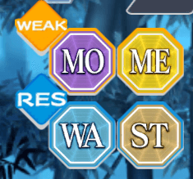
If an enemy takes a hit that’s tagged with an Element they resist, they take 0.5x damage. If a unit takes a hit that’s tagged with a Element they are weak to, they take 2x damage and lose a Barrier (as described in the Barrier section). In short, the difference between hitting a weakness and resistance is a x4 damage gap.
The above multipliers can change depending on a friend’s or enemy’s ability. Best keep a lookout, but more on how these work in a later section!
Guards are a mechanic which lower damage. Guards of the same type do not add, simply the biggest is applied. Multiple applicable guards of different types stack multiplicatively which means unless 1 guard on it’s own reaches 100% damage down, one will always take at least some damage reGUARDless of the guard.
Additionally, you can’t extend guards that aren’t the exact same in both % given and turn amount. What this means is that if you did find a unit with 100% Damage Down from a source for 1 turn and tried to extend it with 30% Damage Down from the same source for 3 turns, 100% Damage down would trigger that turn, leave the next turn, and for the next 2 turns after you’d only have 30% Damage Down.
In addition, there are “All and Solo” Attack Resistance buffs that only enemies get. These act as independent multipliers. For Solo-Targeting Attacks, the formula is 1/(1+.05n). Meaning enemies take 5% more damage from AoE attacks and 5% less from solo target attacks, with a 1/(1+.3n) formula for All-Targeting Attacks which means enemies take 30% less damage from AOE attacks and 30% more from Solo attacks for every rank.

Agility and Turn Priority

Turn priority in Touhou LostWord is very simple and follows a hierarchy. Shots take place after Spell Cards which take place after Last Words. The enemies' spells take place after our Spell Cards and Last Words, but not before our Shots, which are all handled by AGI checks explained later. Quick and Charge make an ally or enemy move first or last in their hierarchy bracket.
Who moves first inside this hierarchy brackets is determined by if said ally or enemy has 20% or more Agility stat, which will mean that Agility plays a key role in who moves first. This Agility stat includes the multipliers from AGI Up. Covered above.
In short this means you must have a 20% AGI lead to consistently outspeed your opponents. Lower than this will result in some degree of rng. For the exact equation of this, consider the following situation. Character A has 1080 agility while character B has 1000 agility. For the exact % chance character A will be outsped by B, use the following equation:
ex if a = 1080, b = 1k, a < 1.2b so %(a outspeed b) = (1.2 * 1000 - 1080)^2 / (0.08 * 1080 * 1k) ~ 16.7%
There is roughly a 16.7% chance Character B will outspeed Character A.
Do not forget the law of diminishing returns here as that is very important with how many units these days scale off AGI. To be honest don’t worry about the % chance to outspeed much, just get guaranteed outspeed.
This means that Cz1 Marisa Kirisame has about a 53.2% chance to outspeed and defeat L80 Reimu Hakurei. Danmaku is surely all about power…err…speed now! (I sure hope C3 Sekibanki doesn’t catch wind of this race.)
A massive thank you and credits toward discord users redd548 and solver1104 for assisting in finding a working universal equation for this section. Solver1104 created the equation and with the help of redd548 it was checked for consistency. Thank you both.

Focus

A stat available only from buffs and debuffs. Any unit with at least 1 Level of Focus Up will be more likely to be targeted by an enemy’s attack - likewise, at least 1 Level of Focus Down will make them less likely to be targeted.
The exact metric for focus up is (1+.3n)^3 while for Focus Down it is (1/1+.3n)^1.5. After this, the damage distribution is calculated with DMG Multi = Focus Up/Down * number of units/(Focus Up/Down of all units added).
Example: Enemy 1 has 0 focus enemy 2 has 10 focus DOWN:
Enemy 1: nothing, equate as 1
Enemy 2: (1/1+.3(10))^1.5 = ¼^1.5=.125
Dmg multi for enemy 1= 1*2/(1+.125) =x1.77_
Dmg multi for enemy 2= .125*2/(1+.125)= x.22_
Enemy 1 takes 77% more damage, Enemy 2 takes about a 5th the damage as normal. Focus down is used as a strategy quite often as because these are different multiplier from everything in the game it stacks and helps counter the ever present extreme damage to effective weighting.

DMG Multi is a straight multi given to the damage one would take.
Focus Up/Down is simply the number given after using one of the two formulas above.
This calculation is run every time an attack lands and works the same for both players and enemies. Once all is said and done, the damage is distributed according to the ratios between the DMG Multipliers given from the Focus buffs/debuffs.
In addition, unlike other buffs or debuffs, Focus UP/DOWN remains on a character once they are in the Full Break state. This can potentially put a Friend with Focus Up in even more danger if they are fully broken, as the increased damage from Focus Up will still apply.

Switch Links and Friendship Bonus

Every unit has a “Switch Link” effect, which does whatever’s listed on their character page - this can range from generating Spirit Power, to recovering Barriers, and more.
Additionally, every unit has a hidden “Friendship Bonus” when switching with certain units, which are usually based on canon friendships and relationships. These friendship bonuses have a chance to occur based on the unit Switching’s Friendship level, and increase the effect of the buff.
Switch Link Effect Guide & List

Morale (outdated needs confirmation)

Units have a "Morale Value," which is measured as follows, based on the icon on their status screen: Overworked (Double Sweat, 0) > Tired (Single Sweat, 1-15) > Energetic (Single Sparkle, 16-60) > Tip-top Shape (Double Sparkle, 61-75).
Morale is capped out at 75 points for units in school, and 60 for those outside of it. Morale is gained at a rate of 1 point per 6 minutes, or 2 points for units in School. It takes a unit in school 3 hours and 48 minutes to hit Max Morale, and a unit outside of it 6 hours.
Morale is lost at a rate of 1 point per battle, with an additional 5 points lost if a unit is knocked out. Retreating from a fight will nullify any morale loss. Units in Tip-top Shape will gain 1.2x EXP and units who are Overworked will gain 0.5x EXP. Units will gain friendship at the end of a battle if their morale is Tired or higher, but will lose friendship if they are Overworked.
Remember you can gain bonus Morale from placing units in the School even when the school is empty of food and they will gain morale while battling!
This means that there is an equilibrium between battling and gaining morale from the school which is roughly 2 minutes and 36 seconds per battle.

Friendship

Units have an "Friendship Value," which is measured as follows, based on the color of the heart on their status screen: So-so (Purple) > Acquaintance (Blue) > Friend (Green) > Close Friend (Orange) > Best Friend (Pink). Newly acquired units start out at Acquaintance friendship.
Units will gain Friendship at the end of a battle if their Morale is Tired or higher, but will lose Friendship if they are Overworked.
Units can gain Friendship by tapping on the hearts which appear over them in School. Additionally, the unit you set as your favorite (the one who appears on your homescreen) will gain friendship over time.
School and homescreen friendship will only raise a unit to about roughly halfway through Close Friend. Best Friend status can only be achieved by battle friendship. The best bonds are those forged in the fires of battle!
High friendship gives additional stats to a unit: approximately +3% at Friend, +6% at Close Friend, and +9% at Best Friend to all stats. This can really make the difference!
Whilst Friendship doesn't take a particularly long time to max out, it is very quickly lost and can be a pain to build back up again, so take care not to send your units out if they have Overworked morale!
Now, the exacts of this work on a base 10k point system. With 0-4999 being purple and increasing upwards until we reach 9899-10000 being pink heart. You gain 11-10 points per victory and lose almost double for matches where you’re exhausted. But to make it clear while sparing detail. It takes roughly 500 battles to reach pink from blue and 1000 from the lowest level of purple to pink.

Combat Power
Combat power is the number next to the letters CP that one will see on any attack. Although not extremely important it will give a rough estimate of how much damage the attack will deal without regards to in-line effects such as Hard/Slice Scaling or Specular bullets. This is primarily useful for comparing defense stats between targets and outside of this holds no true purpose.

Gauges
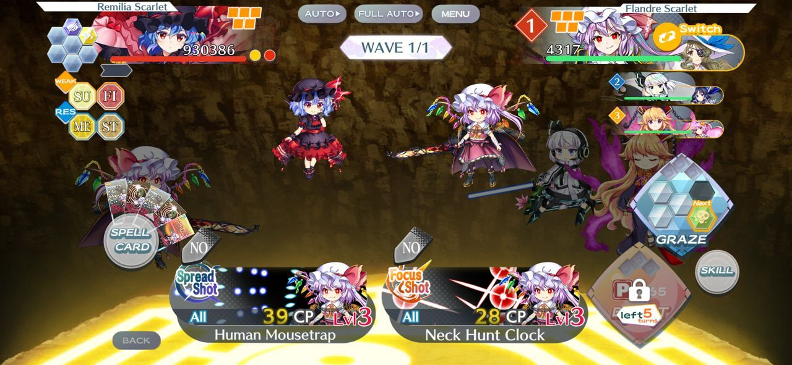
Some challenging content may feature enemies with multiple health bars, known as Gauges.
Beginning from Chapter 3 Act 2, players will start encountering enemies that have more than one health bar. These are known as Gauges, and need to be broken in order to bring the fight to the next phase. More than one enemy may come with a Gauge, and enemies can have up to three Gauges total in a single battle, identified by the Red and Yellow dots that appear next to their health bar. Enemy skills can change between gauges as can many other things about them so click on the Red and Yellow dots for information about the gauge you’re facing.
Gauge Breaking an enemy may also result in additional effects being applied. These generally serve as buffs to your opponents, with a wide range of effects ranging from simple stat boosts, to Element Resistance and the application of Anomalies. Gauge Breaking may also result in your team suffering from Binds/Seals.

Extra Attack

Extra Attacks can seal your team's abilities.
Extra attacks are a mechanic that only takes place during stop points, which happen at the beginning of a wave or on a gauge break. These can have tons of effects and can almost do anything. Most commonly however, they will be used to change the race of the opponent or inflict some sort of Bind. Killer changes or race changes are used to restrict how many Killer tags an enemy is hit by while Binds will remove your ability to perform actions until said Binds are removed. There are quite a few Bind removers, but are usually higher rarity Heal-Class Friends.
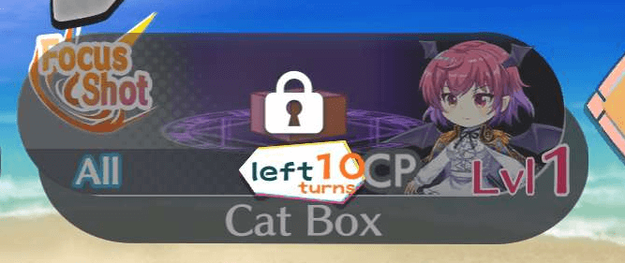
An example of Focus Shot being Sealed.

Overdamage
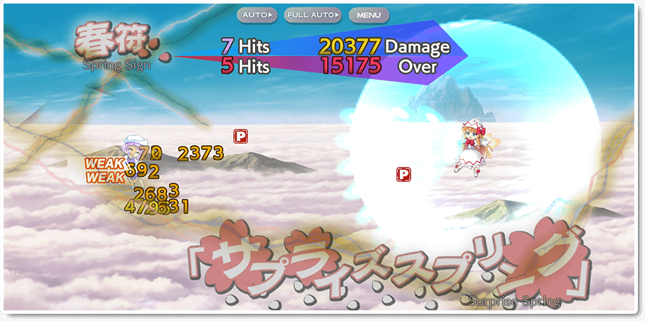
A classic scene of Spring triumphing over Winter. Colourized.
Overdamage was introduced to Touhou Lost Word on November 11, 2022 as part of the 1.5 Anniversary Celebration.
Overdamage is one of the most valued mechanics in Touhou Lostword. In short, for every bullet that hits an enemy after they have been killed, but still have gauges left, you will see red numbers and the word “over” displayed next to them. This tells you exactly how many hits over the enemy’s HP your attack killed their gauge by which can allow the player to know if they need to increase damage to add consistency or not. In addition, if a Spell Card hits an enemy while their Gauge is completely broken, they will receive the entire Spell Card back while the effects still trigger.
Additionally, all hits of Overdamage have a universal Spirit Power collection rate. Even if your unit has a normally very terrible one, this Spirit Power collection rate is also rather high so sometimes running a ATK up Story Card to get more hits of Overdamage (killing the opponent faster and harder) as opposed to a Spirit Power Up Story Card will allow for some pretty wild strategies to become consistent.
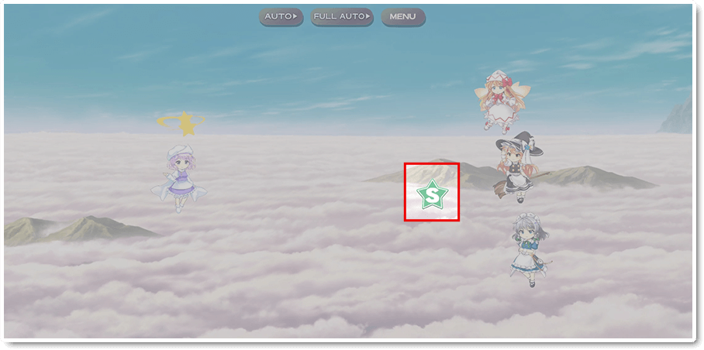
That Spell Card will come in handy for her next Gauge.

VS Divergent Spirits

VS Divergent Spirits is considered to be the primary meat and potatoes of current Touhou LostWord. In order to fully complete it, one must have knowledge of almost everything listed in this guide. However, there is one specific aspect about Divergent Spirits that doesn’t relate to the above portion of this article being the rule system.
VS Divergent Spirits has quite the amount of important or other non-obvious rules, so it is best to go over each of them individually.
Yin/Yang Def UP Is exactly how it sounds: Raising the defense of the enemies by the listed percent value. These stack multiplicatively on each other, meaning two rules that give the enemies 10% more Defense stack to become (1.1*1.1) 21% Defense Up!
HP UP effectively works the same as Yin and Yang Defense up. Stacking on itself. This is clearly observable unlike the defense based rules.
Evasion UP functions very very similarly to Defense Up rules. However, these are still calculated in a similar manner to Accuracy Down and Evasion Up, which have been covered earlier. 20% Evasion Up will result in a x.8 multi at the end of your Accuracy calculation and if the number isn’t above 100 anymore, your allies will still miss despite your attempts.
Damage from Killer bullets DOWN is an interesting case. This rule means that the end of calculation damage from bullets that hit said Killer has a lowered Crit damage output by a set percent, (usually 50%). Killers as such will no longer give a damage bonus for having it and having 0 Crit Attack, with 10 Levels of Crit Attack resulting in a x2.5 Killer multiplier as opposed to the usual x5. As for standard Critical Hits outside of Killers, they remain unaffected!
In VS Divergent Spirits Stages, there is the ever common Buff Removal. Being present in a majority of Divergent Spirits stages, they remove all Rank II buffs from your party, whereas any Rank II buffs, Resonance Skills, Stored Power and other newer mechanics introduced in the later half of 2023 and onward will remain for their usual duration.

Abilities and their Secrets
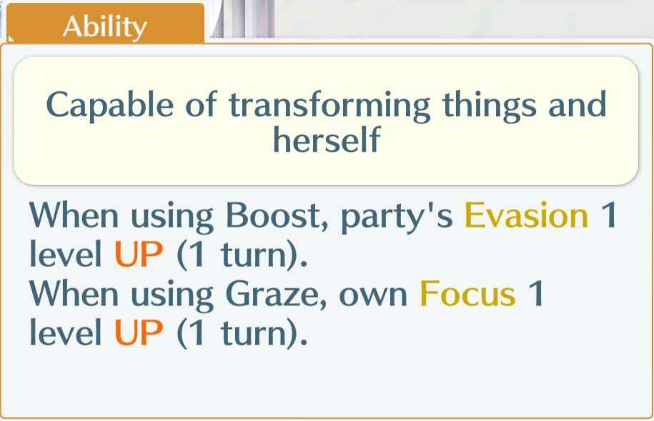
Some abilities are rather easy to understand.
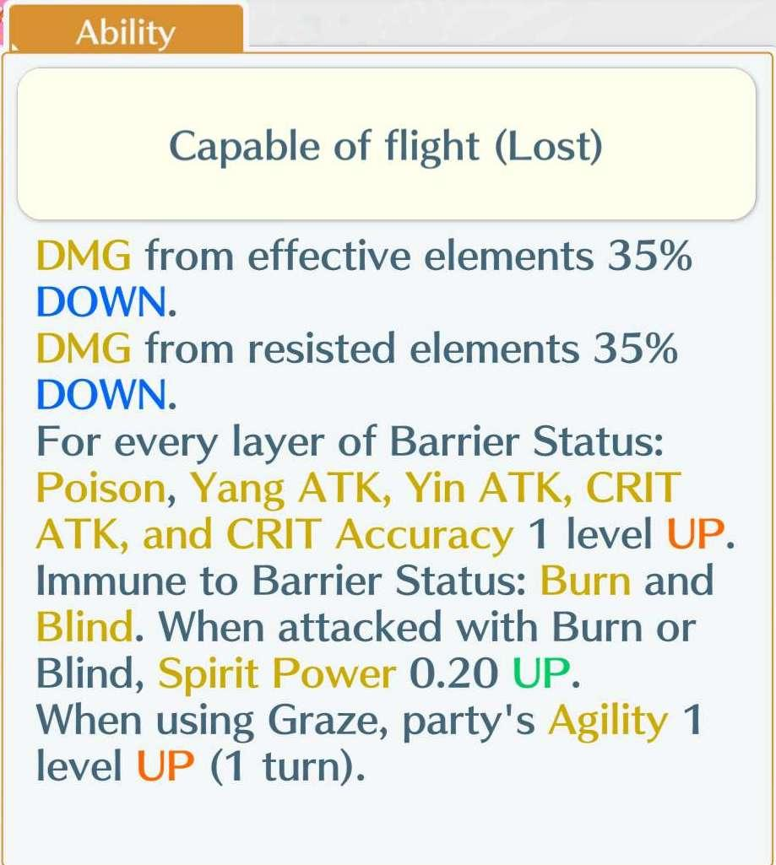
Others…are this shrine maiden here
Abilities are the cornerstone of a good unit. However, there is some worthwhile additional information that will be covered on them that has been found throughout the lifespan of Touhou LostWord..
Damage to resisted/effective elements is a very strong and popular Ability due to how it multiplies, being an additional multiplier when the condition is met. For a character like LR1 Renko Usami (and Shinki), they deal x2.8 damage to effective as opposed to the usual x2 (2*1.4=2.8) leading to a massive ideal damage output. Generally though, damage to resistance is the better of the two.
Damage from resisted/effective elements work the same, as multiplying your defense stat will result in less damage taken. However, there is one massive thing to mention about them. In game, all damage from resisted/effective Abilities are translated incorrectly and should be flipped. All Damage from resistance down Abilities are Damage from effective down for example, and vice versa. Keep this in mind!

Rank II Era Mechanics

Here is a short Glossary of so-called “Rank II Era Mechanics” which are all buffs that are introduced and function in different ways than regular buffs and are not covered by the original Advanced Combat Guide yet have room to be explained further. In addition to what is below all of these buffs will:
- Not be removed by the aforementioned Buff Removal.
- Not lose their effectiveness in the Hakugyoku Arena game modes.
Stored Power. There are three variations of this mechanic in the game at the moment: x20% damage for every 1 Boost in storage (up to 5.00), x15% damage for every Graze (up to 5 Barriers) and x1% damage for every hit point above 80% of maximum HP. All of these award their damage bonus as you press the attack. If one uses Spirit Power based stored power for example, you will receive the maximum damage bonus for the approaching turn even if you boost 3 times assuming you have the maximum 5 total boosts. These are all additive. Meaning 100% damage up for 5 spirit power adds with 75% damage up for 5 barriers. Leading to 175% damage up.
Effective/Resisted Element Up. This simply adds to the current damage to effective/resisted up a unit already has.
Resonance. LM1 Maribel Hearn and Mima’s Skill were covered in depth earlier in this guide. All Genic rarity Friends count as two stacks of this buff, meaning a single unit like LR1 Renko Usami and Shinki gets 10% damage up as they count as two characters instead of the usual one that would only grant a 5% Boost. These do not stack in any manner, the new effect will override the previous one assuming they are the same.
Normal Rank II Buffs. As mentioned earlier, these buffs simply stack on top of what is already buffed as another multiplier. For critical attack Up rank ii specifically, the multiplier only caps at x17. Not x20. So treat this as a x1.17n multiplier. (n being amount of Crit Atk ii Up)
Weakness Infliction. Inflicts weakness to an enemy for a set amount of turns, with Moon and Wood Weakness Inflictions as the only ones available as of the 3rd Anniversary. How helpful!
Great Boundary. Gives specific effects with a particular turn duration. Should the Skill caster switch to the Rear Guard, the stat bonuses will not instantly disappear, but will do so during from moving from one wave to another (like all other skill buffs). Additionally, it makes the background change, which could be deemed a massive visual nerf since some of the backgrounds in this game are great!
Bullet/Ele Type Damage Up. These add to the bullet type modifier gained from cards. So treat a character like C3 Komachi’s last skill as if it gives your characters +20% to their story card buffs. As a result, this is not very impactful of a buff.
X Every Turn. These are pretty self explanatory. They give what is labeled once every turn including the turn you use the initial skill.
Cooldown Reduction. Only thing to mention is that these skills do not effect each other. No spamming CD reduce for infinite skills.

Decay
Introduced on March 3rd in 2023, the term known by the community as Decay was created. Decay slowly increases the stats outside of HP and AGI of the enemies, looking more rampant later into turns, starting on Turn 3 and continuing forever until the battle is over. Additionally, the exact equation is unable to properly be reverse engineered.
Turn 1-2 there is 0 decay.
Turn 3 there is .15% additional stat.
Turn 4 there is .61% additional stat.
Turn 5 there is 1.3% additional stat.
Turn 6 there is 2.23% additional stat.
Turn 7 there is 3.43% additional stat.
Turn 8 there is 4.73 additional stat.
Turn 9 there is 6.33% additional stat.
Turn 10 there is 8.14% additional stat.
Turn 31 there is exactly 100% additional stat.
The steady pace of Decay is overall not very noticeable, at least until higher Defense levels of stages (e.g. VS Divergent Spirits). Should Decay truly be an issue you encounter, try your best to take risks, debuff, or resort to other methods to shorten your clear comp

Reduced Spirit Power Cost
This can be activated by pressing the Spirit Point Cost after pressing the Set Party button when preparing for a battle.
In short, lowering your Party’s cost lowers stats, but does not lower the stat bonuses gained from Story Cards.
The exact amount of stat lowered is n/sp cost amount. Where n is the current sp cost of the unit. This multiplier is added per stat, not to total stat. All stats are rounded to the closest whole number after this cut is applied.
Adding two 12sp units to a battle and reducing the Spirit Point cost to its lowest will result in both units having their stats lowered by roughly 10/24. The reason for the roughly is because of rounding.

When reducing Spirit Points however, each unit is not calculated separately. For example, if you bring 5 5sp units and a 14sp unit, the 14sp unit will have noticeably more stats than if you tried to reduce Spirit Points with just the 14sp unit

